AT HOME MEASURING GUIDE
Measuring your child accurately is the best way to ensure a good fit of their school uniform. This guide will cover the basics on measuring your child for their uniform. We recommend using inches when measuring.
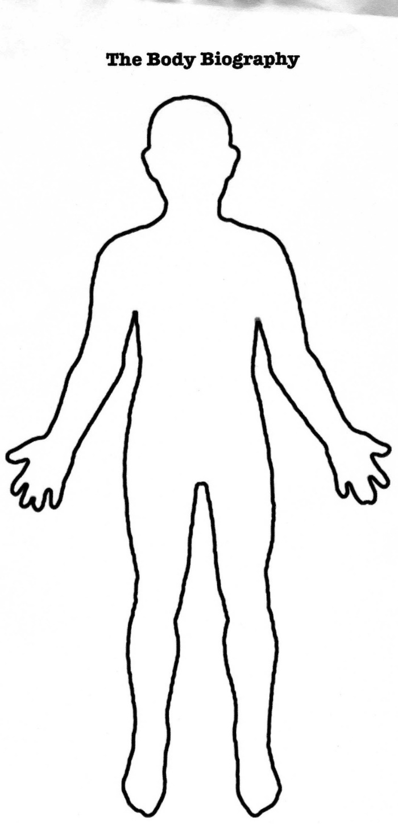
NECK
This measurement is needed for sizing shirts. Carefully measure the neck where a shirt collar would sit. We recommend placing two fingers between the neck and tape measure to ensure the fit is not too tight.
NECK
CHEST
Using a fabric tape measure, wrap it around the child’s chest, under the arms at the widest point.
CHEST
WAIST
Using a fabric tape measure, wrap it around the child’s natural waist, just above the child’s hips.
WAIST
INSIDE LEG
SKIRT LENGTH
This measurement is needed for trouser length. Take a fabric tape measure from the top of the inside thigh to the bottom of the leg when their trousers should fall. We recommend measuring your child’s inside leg when they are wearing shoes to get an idea where the trousers will rest on the shoe.
SKIRT LENGTH
Measure from the natural hip line where the skirt will sit down the legs to desired length. Please note some schools will have a minimum skirt length. For further advice on skirt length please contact the store.
INSIDE LEG

